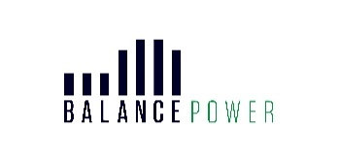
Feedback Form

Leading energy project developer, Balance Power, is proposing to deliver a new battery energy storage system (BESS) development, neighbouring the Coylton electricity substation, located on the A70 between Coalhall and Ochiltree.

A copy of the exhibition boards, and update-to-date information, can also be viewed at: www.coyltonbatterystorage.co.uk and the feedback form is also available here.

We value your feedback and would be grateful if you could complete the following questions.

1. What is your overall impression of the proposals?

2. Which elements of the proposals appeal to you?

3. Are there any elements of the proposals that you think we should reconsider?

4. How useful have you found the consultation event?

5. Please provide any additional comments you would like to make:

PTO

Please return feedback by Friday 20th October 2023 to Orbit Communications, 42 Charlotte Square, Edinburgh EH2 4HQ or by email to hello@coyltonbatterystorage.co.uk

PERSONAL DETAILS (PLEASE PRINT)
Please note all personal information fields are optional.
Name:
Email:
Address: Postcode:

DISCLAIMER
Please note all personal fields are optional.
We only collect personal information when you provide it to us. Your personal data will only be shared within the Coylton BESS planning team. Feedback will be used for specific purposes in relation to the development of the proposal. It will be stored securely until completion of the project, after which this information will be deleted. There will be an opportunity to send comments to East Ayrshire Council in the future when a planning application is submitted. Your personal details will not be forwarded to any third parties without your consent. You can contact us at any time to request the deletion of your information. Please contact us at hello@coyltonbatterystorage.co.uk. Further information on our Privacy Policy can be found at https://www.coyltonbatterystorage.co.uk/privacy-policy/

